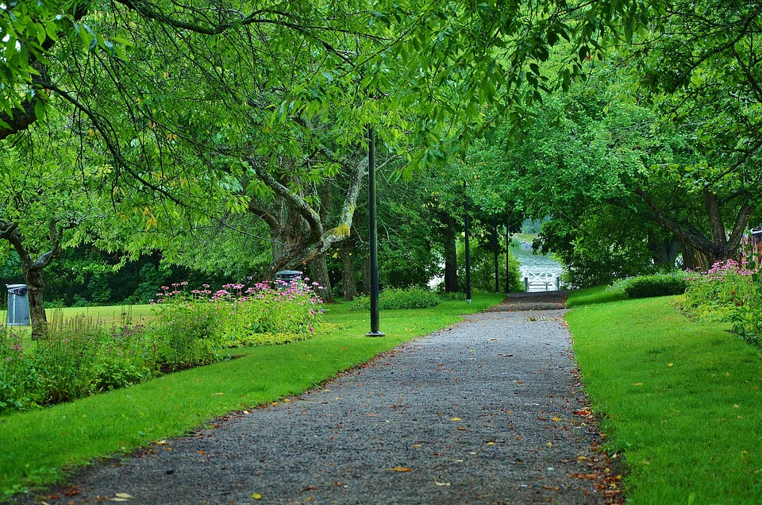

**Annual Report 2024**



*Caring for the health and wellbeing of our community*

**MISSION STATEMENT:** Gunning District Community and Health Service exists to   
provide flexible and co-ordinated community and health services   
to residents of the local community.



**Who We Are – the service – an overview**

|  |
| --- |
| Gunning District Community and Health Service (GDCHS - the Service, also known under the trading name of Gunning Community Care) provides flexible and coordinated aged care, disability, and health services to the community, both in the Upper Lachlan Shire and also short-term care outside this area for urgent respite and transport to doctors and hospitals. We provide services to clients whatever their location, including to remote properties and areas other service providers cannot cover. The Service is committed to assisting aged persons and people living with a disability to stay in their own homes. It also aims to promote healthy living and to support, encourage and develop community initiatives in response to identified community needs.  GDCHS is an incorporated non-government, not for profit association that relies on public, government, and private sector support to fulfil its mission. It is governed by a volunteer management committee that is responsible for the overall management of the Service, setting the strategic direction and overseeing financial and legal governance.  GDCHS receives funding from the Commonwealth and State Governments, Upper Lachlan Shire Council, brokerages from organisations, NDIS and Veterans’ Home Care. This allows the Service to provide a range of services including personal care, domestic assistance, social support and respite to the aged, their families, people living with a disability, and post hospital treatment.  GDCHS also has a general practitioner supported by a practice nurse and medical practice assistant. It also provides community nursing and allied health services under contract or supplied by regional health services including podiatry, physiotherapy, counselling, dietitian, diabetes education, pathology, psychologist, women’s health nurse and child and family nurse. All these services are available at the Service’s premises, the Old Gunning Court House Building, and the Tony Foley Community Centre.  The Service is generously supported by the local community through donations, fund raising and volunteer support. Service partnerships are well established and allow GDCHS to expand its capacity to meet the community’s changing and growing needs. |

**History**

|  |
| --- |
| **In 1979,** Gunning’s resident doctor, Dr Barbour died, volunteer nurses provided services until 1981 when Gunning Home Nursing Service was formed with a small seeding grant and a car provided from the Southern Area Health service. **In 1985,** Home and Community Care (HACC) funding was granted. Services were then provided to the frail aged and younger people with a disability who were residents of the former Gunning Shire (HACC clients).  **In June 1992,** the Service became incorporated as Gunning District Home Support Service Inc. **In 1993**, after a public meeting was held to discuss the future of the service, a community Management Committee was formed.  **In June 1994,** the name of the Service was changed to the Gunning District Community and Health Service Inc. Financial viability was identified as a major issue for the Service. The Gunning Shire Council agreed to provide funding for administration assistance including rent-free premises.  **In** **2000**, the **Sinclair Report** acknowledged the Service as an excellent example of communities working together with government for the betterment of a small rural community. **February 2003**, the Service moved into newly renovated premises at the Gunning Court House with assistance from Federal, State and Local Government contributions.  When the Gunning Shire ceased to exist in **2004**, the Greater Southern Area Health Service agreed that the Service should continue to provide community health services in the area covered by the former Gunning Shire. Consequently, for the purposes of this strategic plan, “Service Area” means the area covered by the former Gunning Shire.  **From 2013**, while still continuing to service parts of the Upper Lachlan Shire Council, GDCHS also provided coverage to parts of the Yass Valley Shire, Palerang Council and Goulburn Mulwaree Council with areas covered including Yass, Murrumbateman, Jeir, Bowning, Binalong, Sutton, and Goulburn.  The growth since 2013 has been led partly by filling an existing need and partly through being requested by broker organisations as a result of the skills and reputation of the dedicated team of Community Support Workers.  **In late 2014**, GDCHS established a medical practice with the aim of contracting in a General Practitioner. The Medical Practice was accredited 18 January 2017 through GPA Accreditation Plus. In addition, a Practice Nurse was recruited to support the GP Clinic.  **In 2016**, GDCHS became NDIS Verified, with acknowledgement of the Service’s capacity to provide the following services: accommodation and tenancy assistance; assistance in coordinating and managing life stages, transitions and supports; assistance with daily personal activities; community nursing for high care needs; assistance with daily life tasks in a group or shared living arrangement; development of daily living and life skills; household tasks; and participation in community, social and civil activities. **In July 2016**, a Gunning Community Care Facebook page was established for communicating with the broader community. **In March 2017** the Gunning Community Care Website was launched.  **In July 2017** the operations of GDCHS was split to reflect a managerial change for the two distinct areas of GDCHS, being Medical and Allied Health and Aged and Disability. An Operations Manager was employed replacing the Executive Officer and was responsible for the Aged and Disability Service and a Practice Manager was employed and was responsible for Medical and Allied Health services.  **In July 2018**, GDCHS began using medical online bookings Health Engine to streamline bookings for the Doctor Practice.  **In February 2019**, the Ageing and Disability portion of the GDCHS business was moved to the Foley Centre where the Community Nurse and Allied Health had previously traded to allow the Medical and Allied Health portion of the business to further grow and to allow cross communication between the Community Nurse, Practice Nurse and Doctor to be more cohesive. **In November 2019** both parts of the businesses, while operating as two separate reporting streams were brought back together under the management of a General Manager.  **In January 2020** GDCHS became an approved Home Care Package provider. **In July 2020** GDHCS enhanced their Ageing and Disability rostering system to an online rostering system “Visual Care”. **In August 2020** Dr Sharin De Silva joined the medical practice team with Dr Sambanthar Muralitharan. **In September 2020** GDCHS took over the lease of the “Meeting Room” of the Tony Foley Community Centre with acknowledging the room be available for community organisations to use with bookings via GDCHS.  **In 2021** GDCHS rebranded their logo, upgraded their website and refreshed internal furnishings to both offices with the assistance from external consultant Vikki Basnett from Stylemill and grant funding from Cullerin Range Wind Farm. **In March and September 2021** two fleet vehicles were upgraded and the service purchased two new SUVs. **In July 2021** GDCHS became a registered NDIS provider and passed accreditation. **In August 2021** GDCHS Medical Practice was approved to provide COVID-19 Vaccinations to the Gunning Community and surroundings. . In **September 2021** a new role ‘Rostering Officer’ was introduced in the Aged and Disability area to assist with the growth of the business.  **In 2022** GDCHS expanded their Community Nursing area to Collector, NSW and provided an outreach nursing service for over 65 clients. **In February 2022** a Medical Practice Assistant role was introduced into the Medical and Allied Health area to assist with the growth in the medical side of the business. **In June 2022** a new online training platform ‘Healthcare Australia was introduced for all staff. **In July and August 2022,** the service held their main fundraisers for the Service ‘The Long Yarn Lunch’, supporting Rural Men’s Health, and a ‘Ladies Lunch’ supporting Rural Women’s Health to assist in the purchase of a fully installed backup generator for the health service.  **In 2023** GDCHS expanded their Allied Health Services such as a Denture Clinic by Rebecca Betz from Country Wide Dentures, employment of Women’s Health Nurse Leah Lloyd and Physiotherapist Georgina Mitchell. **In March 2023** Dr Roshan Dalpadado joined the medical team as the principal GP. **In May and September 2023** the service held their main fundraisers for the service “The Long Yarn Lunch” and “The Gathering at Gunning” to raise funds to upgrade our bus with disability and aged care accessibility.  **In** **August 2023** GDCHS successfully completed all three reaccreditations for NDIS, Home Services Aged Care and Medical Practice. **In Dec 2023** GDCHS hosted a successful Gunning Christmas Twilight Markets for the local community.  **In 2024** GDCHS expanded their medical professional team with the addition of a Specialist Geriatrician - Dr Sasikala Selvadurai on a Thursday. **In Jan 2024** GDCHS successfully acquired the Lions Units which will be the new Aged Care and Disability offices and GDCHS was successful in re-accreditation for Home Care Packages and CHSP Programs. GDCHS proudly supported the local Gunning Show in **Feb 2024** by providing a canteen in the pavilion, which was manned by our volunteers. **In May 2024** GDCHS hosted another successful Men’s Lunch which raised funds to complete the purchase of our new bus. **In June 2024** an upgrade of telephone, server and computer software was completed. **In Sept 2024** GDCHS also hosted another successful Ladies Lunch with the funds raised being the final amount needed to purchase the bus and passed NDIS re-certification. |

**Gunning District Community and Health Service Incorporated - Management Committee 2023-2024:**

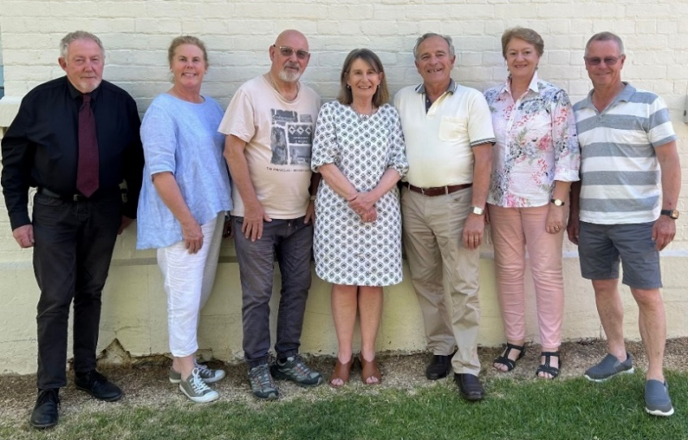

**President** Melinda Medway

**Vice President** John Shaw OAM

**Treasurer** Diego Ferraris

**Secretary** Michael Coley

**Committee Member**  Rachael Foley

**Committee Member** Patricia Hallam

**ULSC Representative** Councillor John Searl

**President’s Report**

Thank you all for attending our 2024 AGM, 2024 was again another successful year for Gunning District Community and Health Service.

I would firstly like to thank my fellow committee members John Shaw, Michael Coley, Diego Ferraris, Trish Hallam, Rachel Foley and John Searl for all the volunteer hours they have provided the service.

Our General Manager, Katie Yeo excelled in her role with her commitment to the Gunning Community and the service in 2024.

The key outcomes for 2023-2024 are as follows:

* A successful “Twilight Christmas Markets “hosted by the service and enjoyed by everyone in the community.
* Successfully acquiring the Lions units for the Service.
* Men’s and Ladies Lunches.
* Upgrading of the services computer, telephones, and server.
* Additional purchase of the new bus to add to our fleet and for the use of the community.
* Passing NDIS re–certification and
* We were extremely blessed to have been the beneficiary of Meg Perry Carters Estate.

Sadly, Katie left her role as General Manager in August this year. I would like to take the opportunity to thank her for all she has accomplished in her 5 years as General Manager and wish her every success in her future endeavours.

Veronica Leon is our new General Manager and comes to us with extensive experience in financial management, people management and operations from a 14 year career with one of Australia’s largest banks. We feel that the service is in very good and capable hands moving into the future.

We currently employee 29 fantastic and dedicated staff and are constantly advertising for Aged Care and Disability Workers as our health service continues to grow.

Our Aged Care and Disability area services an amazing 122 clients and our current active medical patients is 1,565, which saw an increase of 137 patients this year.

I am so proud of our Health Service and the Services that we are able to provide to our beautiful community.

***Melinda Medway***

*President - Gunning District Community & Health Service Inc*

**Treasurer’s Report**

The Financial Statements for the year ending 30 June 2024 have been prepared by our Accountant and have been audited by our Independent Auditor.

The operating environment returned to normal following the Covid pandemic period. It was a year of higher capital investment with the remainder of the vehicle fleet being refreshed as well as the purchase of property to provide the Service with the option to build purpose-built accommodation and move away from current leased properties. Surplus from operations was boosted by a substantial bequest from a long term client of the Service and asset base was also substantially boosted by in-kind donation on the purchase of the property. The Service ended the 2024 year with: a surplus of $1,620,627; total assets of $2,981,700; and a bank balance of $1,731,992.05. The current ratio of 9.52 is indicative of very sound financial health and adequate funds to continue operations.

The key contributors to the 2024 surplus were the bequest of $714,311 and acquired property valued at $849,000.

The result for the Service’s two business streams Medical Practice and Operations were as follows: Medical operated at a small loss Of $10,715; and Operations operated profitably with a surplus of $67,560 (excluding the $714,311 bequest). The Medical Practice business revenue was adversely affected by increased staff cost; and the Operations business revenue was impacted by higher planned capital expenditure and increased staffing costs.

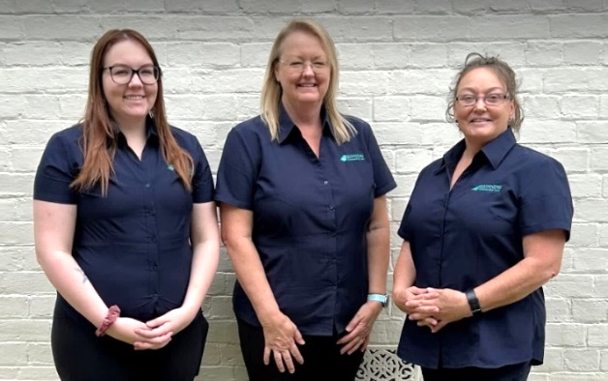

**Year on Year comparison**

|  |  |  |  |
| --- | --- | --- | --- |
|  | 2024 | 2023 | Outcome |
| REVENUE | $4,348,249 | $2,567,909 | +170.66% |
| EXPENSE | $2,777,187 | $2,203,691 | +12.60% |

In summary, Financial Year 2024 saw income increase by 170.66%, expense increasing by

12.60%. Excluding the $714,311, revenue increased by approx. 14.15% compared with 2023

which is more in line with trend over recent financial years.

**Finance and NDIS Team**

Ashleigh Hewett, Allana Carmody and Debra Wilson

***Diego Ferraris***

*Treasurer - Gunning District Community & Health Service Inc*

**Community Services**

The Service continues to provide home care support for clients and reaches out to the local community to provide care and support and to develop strategies to provide quality services.

We advertise our services through our website, Facebook and various health directories as well as being able to provide an online booking service for the GP and Allied Health specialists via a program called Hot Doc.

|  |  |
| --- | --- |
| **Current Service Activities:**   * Home Care Packages * Community Nursing * NDIS * Frozen Meal Service * Personal Care * Domestic Assistance * Respite Care * Group social support * Individual social support * Transport * Meal Preparation * Free Equipment Hire * Health Promotion * Information and Referral * Individual Social Support * Advocacy * Short-term ‘after hospital’ assistance,   generally called Transitional Aged Care | **Groups and Activities:**   * Monday Social Group * Wednesday Bus Trips |

Back: Janice Rowell, Carol Kofinas, Emily Polsen. Mike Coley, Andy Wright, Janelle Morris, Megan Polsen

Front: Lyn Jeffrey, Kim Edwards, Maree O’Brien, Monique Hillier, Nikki Faulkner, Julie Priestly, and Lucy Dowling

**Medical Practice, Nursing and Allied Health**

The Medical Practice has been going extremely well over the past 12 months with the introduction of many new services and team members and welcomed back from maternity leave our Physiotherapist Georgina Mitchell in 2024,

The Medical Practice team is led by Medical and Allied Health Team Leader Chloe Johnson who is supported by General Manager Veronica Leon, Practice Nurse Rachel Sergeant, Medical Receptionists Maree O’Brien and Amanda Evans, Women’s Health Nurse Leah Lloyd, and Physiotherapist Georgina Mitchell.

The Community Nursing team of Kim Shorter and Rachel Sergeant, play a pivotal role in the community and assists the doctors with any follow up appointments, dressing changes, home visits as well as health assessment and monitoring domiciliary nursing wound management, palliative care, oncology support, chronic disease education/support, child and family health, indwelling catheter management with supra pubic catheter care as well as NDIS support.

Our community nurses are currently available on Monday, Wednesday, Thursday and Fridays, and other days when required from 9.00am at the Courthouse Building.

We were fortunate to employ Women’s Health Nurse Leah Lloyd who provides an amazing women’s health clinic to the female population of our community on a Monday every fortnight. Leah is a Registered Nurse with a Graduate Certificate in Women’s Health Medicine, Reproductive & Sexual Health Clinical Accreditation Program and Trainer Teacher in Natural Fertility Education Certificate.  Leah’s appointments are a free service with the assistance of funding from the “Upper Lachlan Foundation”.

Social Worker Amanda McCarthy has increased her days due to being booked to capacity and is now available every Monday and Wednesday.

Our contracted Podiatrist Timothy Gale is a much-needed asset to our Allied Health team with full bookings each week and a current waitlist of around four weeks.

The following Allied Health clinics operate on different days of the week, and are also available in the practice:

|  |  |
| --- | --- |
| * Pathology * Physiotherapy * Podiatry * Early Childhood, Family, and Immunisations * Phlebotomy | * Counsellor and Psychologist * Women’s Health Nurse * Social Workers * Specialist Geriatrician |

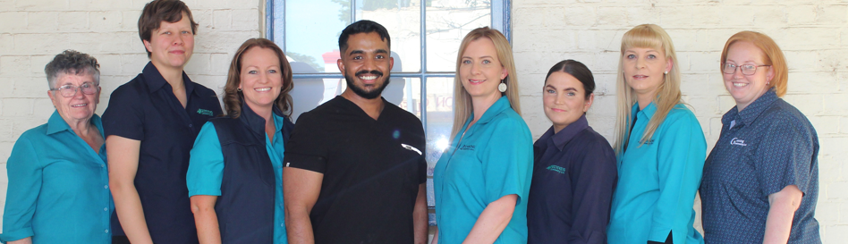

**Medical Practice Team**

Maree O’Brien Georgina Mitchell, Leah Lloyd, Dr Roshan Dalpadado, Veronica Leon, Chloe Johnson, Amanda Evans and Rachel Sergeant

**2024 Key Achievements**

|  |  |
| --- | --- |
| * Purchase of one (1) extra fleet vehicle (Bus) * NDIS re-certification * Acquired the Lions Units * IT server upgrade * Telephone and computer upgrades * Men’s Lunch “The Long Yarn” * Ladies Lunch “The Gathering | * Generator purchase and instalment * Specialist Geriatrician joined medical practice |

**Fundraising and Grants**

Our main fundraisers for 2024 were a Rural Men’s Health Day, “The Long Yarn Lunch” and a Rural Women’s Health day “The Gathering of Gunning” with both held at the Old Coach Stables in Gunning. Both events were a great success with a sellout of attendances with many of whom travelled from across the state.

These events provide an opportunity for our men and women in our community to connect and enjoy each other’s company on the day, with funds being raised this year to be directly used by GDCHS to purchase a new bus with disability and aged care accessibility for people in the community to use on group outings and social events.

Thank you to our wonderful volunteer organisers of the events, Campbell Basnett, Luke Dowling, Vikki Basnett. Skye Manson and Jo Basnett.

Several organisations have provided much-needed grants to assist the Service, including:

|  |  |
| --- | --- |
| * Acciona * Cullerin Range Wind Farm * Coordinare * Veolia Mulwaree Trust * Lions Club of Gunning | * Collector Wind Farm Pty Ltd * Lindsay Dove Foundation * Upper Lachlan Foundation * Telegraph Hotel Gunning * Gunning Wind Farm |

**Client Centered Services**

**Monday Social Group – *Janelle Morris (Group Coordinator)***

Our Monday Social Group is currently funded by the Commonwealth Home Support Program. The group of six to seven participants meet every Monday for social activities and outings at the Tony Foley Centre Activities Room.

Activities for this year have ranged from road trips to Bungendore, Jugiong, Bookham and Harden and we have supported our local businesses by having lunch at the local Telegraph Hotel, the Merino and Old Hume Cafes.

Other activities have included:

* bingo
* cooking days *(with lots of discussion on the best recipe for scones)*
* high tea
* games
* movie days
* arts and crafts
* guest’s speakers such as Services NSW who presenting key benefits and incentives for aged care recipients and
* Open Mobility provided a demonstration display and information session on equipment.

Support is also provided to our clients/participants by telephone during periods where they were not able to attend Monday social group.

I would like to thank our volunteer Sharon Chan and employee Julie Priestley for their participation and assistance with activities during this year, which all group members have thoroughly enjoyed.

**Men’s Group – *Janelle Morris (Group Coordinator)***

Our Men’s Social Group is currently funded by the Commonwealth Home Support Program and unfortunately due to low attendance, the Men’s group has been placed on hold until the 2025 year.

**Wednesday Bus Trips – *Janelle Morris (Group Coordinator)***

This group is organised for every Thursday of the month and is provided for people that are more independently mobile and many thanks to volunteer Christine Mitchell who volunteers her time to drive the bus to Goulburn each month. This service has been received well from the community with regular attendees each week.

**AuspicedGroups**

**Gunning Shower Singers – *Bob Spiller***

GDCHS auspices a singing-for-pleasure group, the Gunning Shower Singers, which meets weekly in the Tony Foley Centre. Group convenor Margaret Dougall says that her observations and informal feedback from members show Shower Singers provides a valued activity to participants.

Margaret says Shower Singers is an appropriate thing for GDCHS to support. Scientific studies consistently show singing with others can improve mental and physical health. And Margaret believes her fellow choristers are almost certainly bettering their well-being.

Gunning Shower Singers organisers have often expressed their appreciation to GDCHS for allowing them access to the Centre, which is ideal for their needs. In particular, they have praised GDCHS staff Maree O’Brien, their primary contact for using the Centre. They say Maree always ensures the venue is ready and, regularly as an alarm clock, phones through the door PIN code every Monday morning.

**Gunning Focus Group – *Bob Spiller***

Gunning Focus Group (GFG) hosts concerts in the Gunning Courtroom during the year. GDCHS helps these events run smoothly and successfully by allowing GFG access to its entrance and passageway when needed. This enables disabled people to enter and gives performers a space in which to wait and prepare themselves before entering the venue.

GFG greatly appreciates this assistance, which is acknowledged in its promotional material and concert programs and included in announcements to audiences.

**Service Workforce**

The Service’s team, as usual have worked very hard and have a brilliant reputation for their person-centered care; our client feedback reflects this as does the feedback from other organisations. Every single member of our team is truly appreciated.

The GDCHS team have the key qualities of respect, honesty and integrity that enables everyone to work collaboratively with shared vision and goals.

**Recruitment and Orientation**

We have experienced Community Support Workers who reside in all areas such as Goulburn, Yass, Murrumbateman and Gunning. All new staff, volunteers and committee members have current police checks, NDIS Worker Screening checks and have undergone an orientation/induction session.

**Training and Professional Development**

The organisation requires that all Community Support Workers have or are training for a Certificate III in Community Services (Aged Care or Disability) or equivalent.

All staff undertake annual training which includes First Aid, CPR, Defibrillator training as well as other training which includes:

* Medication Awareness and Safety
* Complex Bowel Management and Indwelling Catheter management
* Food Handling
* Fire, Food and Chemical Safety
* Risk Awareness and Risk Safety
* Manual Handling
* NDIS Worker Orientation Module and
* COVID Infection Control.

This year staff Julie Priestly completed her diploma in Community Services and Veronica Leon completed her Certificate III in Individual Support and Certificate IV in Aging Support.

**Volunteers**

We are very lucky to have a pool of wonderful volunteers who we can call upon for numerous tasks within our organisation.

Thank you to our fantastic volunteers Michael Coley, Christine Mitchell, Kerry Gribbin, Sharon Chan, Margaret Dougall, Vikki Basnett, Jo Basnett, Luke Dowling, Campbell Basnett and Skye Manson.

We could not manage without the support of our volunteers who bring an array of skills and talents that improve the service for all.

**Community Participation**

**Membership**

The Association has over 300 members currently on our list and as per the GDCHS Constitution, a membership of the association must pay to the association an annual membership fee of $2, or if another amount is determined by the committee.

**Feedback Box**

A feedback box is currently located outside medical reception *(letter box main entrance)* at GDCHS Courthouse Building or the Foley Centre and we are always welcome to suggestions and feedback.

**Website and Facebook and other Media**

Our website and facebook continue to be our main communication to the community of the services we provide and the positive results from both have assisted us to reach over 993 followers.

We have clearly made an impact with people accessing services that they would not normally and can advertise positions vacant, sale items, activities, and events.

We will continue to expand this service, along with the use of local media such as the Upper Lachlan Paper and advertising at local shops to try and reach every person in our community.

**Partnerships with other organisations**

**Upper Lachlan Shire Council**

Our partnership with Upper Lachlan Shire Council continues on solid ground. Council provides the courthouse free of charge to the Service and without this support the Service we would not be viable. Our thanks also to Council for the maintenance and upkeep of the building and grounds.

**Delivery of Services for our Partners**

As we continue to build on our partnerships, we have developed several key brokerage contracts with regional centres for GDCHS to deliver services on their behalf.

Brokerage contracts throughout the year have been with:

|  |  |
| --- | --- |
| * Department of Veterans Affairs * Uniting * Integrated Living Australia * Interchange Australia * Catholic HealthCare * Coordinare * NDIS * Anglicare * Gunning Handyman * Collector Painting Services * Baileys Garage * Gunning Service Centre * Medway’s Garage Dalton | * RSL Life-Care * Community Options Australia * Catholic Care Canberra and Goulburn * Illawarra Retirement Trust Home Care * Life Without Barriers * Kincare * Meaningful Assisted Care Services * Bern’s Mowing and Gardening * PL Lawn Mowing Property Maintenance * Mum & Dad’s Laundry & Car Spa * Gunning Motors * Spark it Right * Community Services One |

Gunning District Community and Health Service Inc would like to thank and recognise ongoing funding support from our funding partners:

|  |  |
| --- | --- |
| * Commonwealth Department of Health and Ageing * Department of Veterans’ Affairs * Upper Lachlan Shire Council | * Commonwealth Department of Families, Housing and Community Services and Indigenous Affairs * The NSW Department of Health * Residents of the Gunning and local community |

We also would like to thank everyone who attends our major fundraisers each year at our Men’s and Ladies luncheons.

Funding received from these events have been able to provide much needed support to purchase larger items that will benefit the business long term.

**Gunning District Community and Health Service Inc – Staff for 2024**

